**What is an Inductive Transducer?**

**Definition:** A transducer that works on the principle of electromagnetic induction or transduction mechanism is called an inductive transducer. A self-inductance or mutual inductance is varied to measure required physical quantities like displacement (rotary or linear), force, pressure, velocity, torque, acceleration, etc. These physical quantities are noted as measurands. [Linear Variable Differential Transducer (LVDT)](https://www.watelectronics.com/lvdt-linear-variable-displacement-transformer/) is an example of an inductive transducer. Using LVDT, displacement is measured in terms of the voltage induced in the winding by moving the core in one direction.

Types of the Inductive Transducer

Inductive transducers may be of passive-type or self-generating type. The tachometer is the example of a self-generating inductive transducer. LVDT is an example of a passive type inductive transducer.  
Inductive transducers are divided into two types. They are,

Simple Inductance Type

In this type of transducer, a single coil is used to measure the required parameter. The change in displacement changes the permeability of the flux produced in the circuit results in a change in the inductance of the coil and the output. The output can be calibrated in terms of the measurand, which is to be measured. The circuit of a simple inductance type is shown below. Single inductance type is again divided into two types.

**Single Coil Inductance Type**

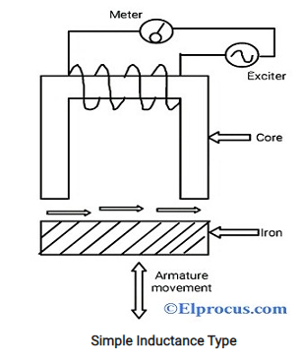

When the armature of the circuit is moved, the air gap between the [magnetic materials](https://www.watelectronics.com/what-are-ferromagnetic-materials-magnetization-their-applications/) and the permeability of the flux produced in the circuit changes. This results in a change of the inductance in the circuit. This type is used mainly in counting the no.of objects. The circuit of a single-coil inductance type is shown below.

**Hallow Coil Inductive Type Circuit**

The magnetic core can be moved inside the hallow material, which has a coil wound around the hallow magnetic material The output is proportional to the input and it can be calibrated in terms of the measurand. The air gap decides the change in the magnetic field of the coils and the flux linkage.

**Mutual Inductance Transducers (two coils)**

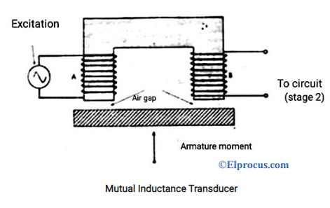

In this type, two coils are used for mutual induction. One for generating excitation and another for output. The voltage difference between the two coils depends on the movement of the armature. When the armature position is changed by connecting to the movable mechanical element, then the inductance changes. The air gap between the armature and the magnetic material and also voltage induced in the coil depends on the change in the armature position. This type is also called a differential mutual inductive transducer.

**Capacitive Transducer**

**Definition:** The capacitive [transducer](https://circuitglobe.com/transducer.html) is used for measuring the displacement, pressure and other physical quantities. It is a passive transducer that means it requires external power for operation. The capacitive transducer works on the principle of variable [capacitances.](https://circuitglobe.com/what-is-a-capacitance.html) The capacitance of the capacitive transducer changes because of many reasons like overlapping of plates, change in distance between the plates and dielectric constant.

The capacitive transducer contains two parallel metal plates. These plates are separated by the dielectric medium which is either air, material, gas or liquid. In the normal capacitor the distance between the plates are fixed, but in capacitive transducer the distance between them are varied.

The capacitive transducer uses the electrical quantity of capacitance for converting the mechanical movement into an electrical signal. The input quantity causes the change of the capacitance which is directly measured by the capacitive transducer.

The capacitors measure both the static and dynamic changes. The displacement is also measured directly by connecting the measurable devices to the movable plate of the capacitor. It works on with both the contacting and non-contacting modes.

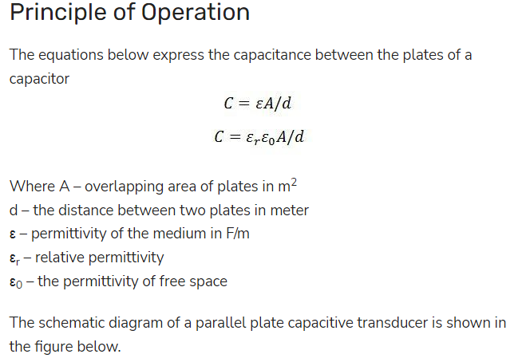

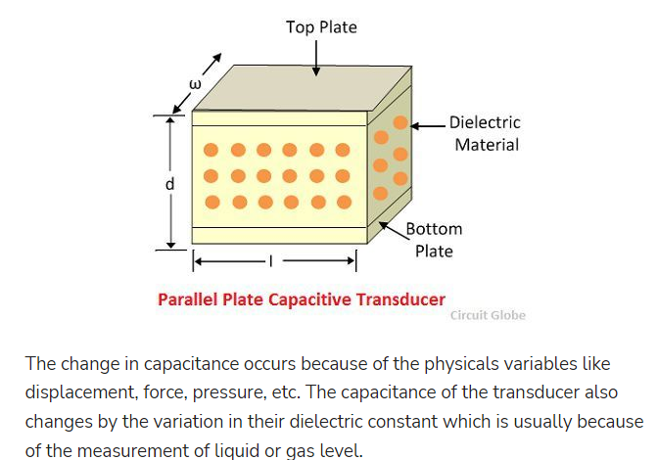

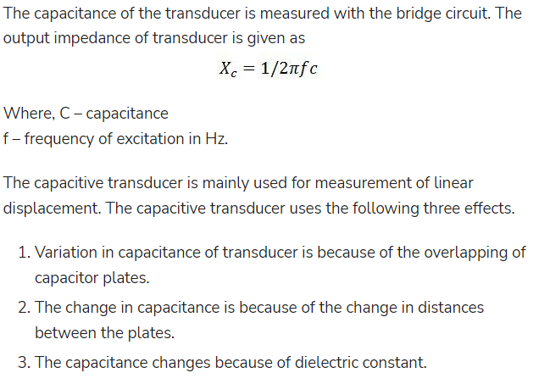

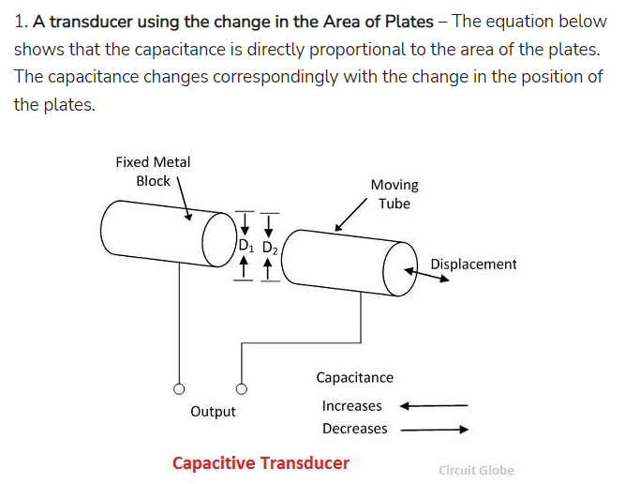

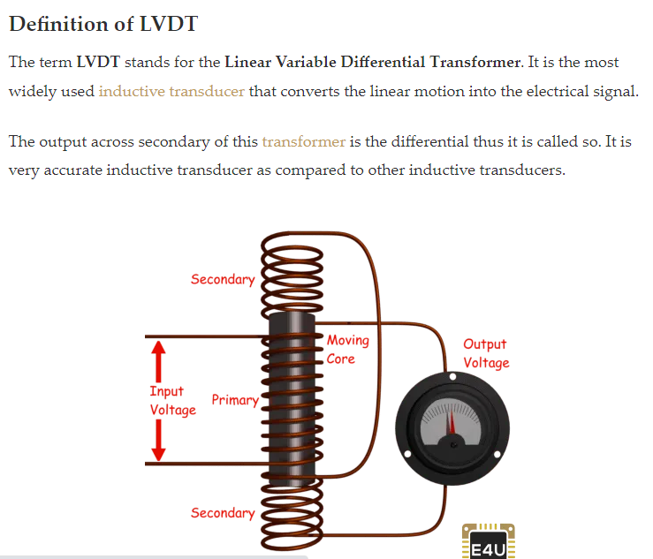

**Definition of LVDT**

**The term LVDT stands for the Linear Variable Differential Transformer. It is the most widely used** [**inductive transducer**](https://www.electrical4u.com/inductive-transducers/) **that converts the linear motion into the electrical signal.**

**Main Features of Construction**

* **The transformer consists of a primary winding P and two secondary windings S1 and S2 wound on a cylindrical former (which is hollow in nature and contains the core).**
* **Both the secondary windings have an equal number of turns, and we place them on either side of primary winding**
* **The primary winding is connected to an AC source which produces a flux in the air gap and voltages are induced in secondary windings.**
* **A movable soft iron core is placed inside the former and displacement to be measured is connected to the iron core.**
* **The iron core is generally of high permeability which helps in reducing**[**harmonics**](https://www.electrical4u.com/fundamental-frequency-and-harmonics/)**and high sensitivity of LVDT.**
* **The LVDT is placed inside a stainless steel housing because it will provide electrostatic and electromagnetic shielding.**
* **The both the secondary windings are connected in such a way that resulted output is the difference between the voltages of two windings.**

**Photoelectric cell**

**also called Electric Eye, Photocell, or Phototube, an**[**electron tube**](https://www.britannica.com/technology/electron-tube)**with a photosensitive**[**cathode**](https://www.britannica.com/technology/cathode)**that emits electrons when**[**illuminated**](https://www.merriam-webster.com/dictionary/illuminated)**and an**[**anode**](https://www.britannica.com/technology/anode)**for collecting the emitted electrons. Various cathode materials are sensitive to specific spectral regions, such as ultraviolet, infrared, or visible light. The voltage between the anode and cathode causes no current in darkness because no electrons are emitted, but illumination excites electrons that are attracted to the anode, producing current proportional to the intensity of the illumination. These tubes are used in control systems, where interrupting a beam of light opens a**[**circuit**](https://www.britannica.com/technology/electric-circuit)**, actuating a**[**relay**](https://www.britannica.com/science/relay-electronics)**that, in turn, supplies power to a mechanism that brings about the desired operation, such as the opening of a door. The tubes are also used in photometry and in spectroscopy.**

**Photovoltaic Transducer :**

**A photovoltaic (PV) transducer or cell is a device that converts light energy into electrical energy through the photovoltaic effect. It is an active transducer, also known as a solar cell. The output electrical energy produced is proportional to the intensity of light.**

